Daniella Brito

**HOW TO TYPE HELLO WORLD ON ARDUINO**

CODE

Establish the Liquid Crystal as a variable before the set up

const int

LiquidCrystal lcd

**In the Set- up section:**

-define the maximum number of characters and rows you want to display on the LCD.

-the next line prints the message to the screen; must not exceed the number of characters you have established in the line above.

**In the Loop section:**

first line in loop establishes where the characters will be on the screen, counting characters begins with 0, so in the code you write lcd.setCursor(0,1); meaning, line 1 is in the second row.

the last line prints the number of seconds since arduino resets.

first row contains static message, second row, shows the counting seconds.

**CODE:**

const int rs = 12, en = 11, d4 = 5, d5 = 4, d6 = 3, d7 = 2;

LiquidCrystal lcd(rs, en, d4, d5, d6, d7);

void setup() {

// set up the LCD's number of columns and rows:

lcd.begin(16, 2);

// Print a message to the LCD.

lcd.print("hello, world!");

}

void loop() {

// set the cursor to column 0, line 1

// (note: line 1 is the second row, since counting begins with 0):

lcd.setCursor(0, 1);

// print the number of seconds since reset:

lcd.print(millis() / 1000);

}

**WIRING**

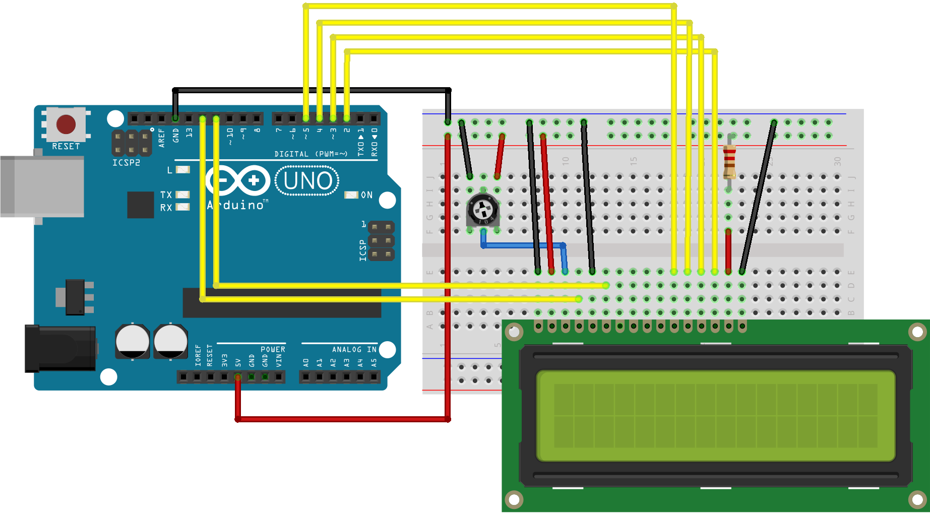

A desk with a computer sitting on a table

Description generated with very high confidence